CSC5008Z Exam

**Sameshan Perumal**

***PRMSAM001***

2018-05-31

# Question 1: Analysis

## Visualisation overview

The graphic under consideration is **Oil Well,** a visualisation of various properties cooking oils. The primary goal is to allow health aspects of each oil to be compared, whilst also differentiating between the suitability of each oil to various uses, with the ultimate desired outcome being behavioural changes in consumption patterns.

The graphic uses the somewhat related metaphor of an oil well (from which crude oil is generally extracted) to create a gist, with colder oils toward the bottom of the well, and lighter, hotter oils toward the top. This is only partially successful, as edible oils never come from wells, and well contents tend to get warmer the deeper you get.

The gist is further supported by the use of colours that evoke different types of oil (notably **red** = chilli, **yellow** = most oils, **green** = olive oil), which is more successful. The actual effectiveness of the colour choices will be discussed in detail below.

## Dimensions

There are a number of dimensions available in the underlying dataset, only a subset of which have been used in the visualisation – underlined items below have not been used in the original visualisation:

* **Oil name:** Common name or source of the oil.
* **Oil sub-type**: Differentiates between sub-types of the same oil. Can either refer to processing or source.
* **Taste**: A 3-level indicator of how strong/distinctive the oil is. Available values are: 0 = neutral; 1 = gentle; 2 = strong/distinctive/nutty.
* **Cost**: The average cost UK cost per 100ml in dollars. This is a potentially important deciding factor if consumption behaviour is to be changed, as many good choices may simply be unaffordable to for some proportion of the target audience.
* **Saturated %:** The proportion of each oil that is composed of Saturated fats, which are generally considered to be unhealthy.
* **Polyunsaturated %:** The proportion of each oil that is composed of Polyunsaturated fats, which are generally considered to be healthier, though a distinction must be made between omega 3 and omega 6.
* **Unsaturated %:** The proportion of each oil that is composed of Saturated fats, which are generally considered to be unhealthy.
* **Other fat %:** The proportion of each oil that is composed of any type of fat other than the 3 listed above.
* **Other things %:** The proportion of each oil that is composed of non-fat components (water, protein, etc.).
* **Omega-3 %:** The proportion of each oil that is composed of omega-3 fatty acids, which are healthier.
* **Omega-6 %:** The proportion of each oil that is composed of omega-6 fatty acids, which are unhealthy.
* **Omega-6 to Omega-3 ratio:** This ratio is important as omega-3 competes with omega-6 for absorption.
* **Trans-fat %:** The proportion of each oil that is composed of trans-fats, which are unhealthy.
* **Refrigerate:** An indicator as to whether the oil needs refrigeration. Not used, but potentially important in the same way cost is.
* **Smoke point (C and F):** The temperature at which the oil begins to smoke, and beyond which it should no longer be used. Determines what uses the oil is suitable for.

## Visual queries

The dataset lends itself to a number of visual queries, with the primary queries relating to health benefits, and the secondary queries relating to usability. Potential queries are discussed below in decreasing order of importance:

* What is the healthiest oil I could consume?
* Which oils should I avoid in future, that I currently consume?
* Which oils that I currently do not consume, should I consume more of in future?
* What healthy oil should I use when deep frying?
* Can I use unrefined coconut oil while stir-frying?
* Should I use cashew or sesame for a nutty flavoured sauce?
* Will Argan oil overwhelm my salad?
* Which is the most cost-effective and healthy oil to buy for my family?

## Channel analysis

The Oil Well visualisation uses a small subset of available information channels.

### Colour

Colour is only used as a categorical indicator to group information by the type of fat it relates to. This is an effective use, particularly given the small number of primary colours used and the relation between the chosen colours and the gist previously discussed.

A potential problem is that the use of red and green might be problematic for the most common type of colour-blindness, but this is mitigated the design choice to spatially separate all instances of each colour with yellow elements. The same applies to possible yellow-blue colour-blindness (despite it being much rarer).

More problematic is the specific shade of yellow used (particularly for the text), which can be difficult to distinguish against the white background (this is exacerbated when the luminance of the yellow is lowered as you descend the well). This could be mitigated by switching to a black or dark coloured background.

### Font

This visualisation uses an overwhelming number of fonts, to the point where they become noise rather than carrying useful any information. Each element type (headings, descriptions, labels, etc.) appears to use a different font, which wouldn’t necessarily be a problem except that this channel is overloaded through use in at least 3 other contexts.

Each type of oil uses a different font, for no apparent reason other than that it was possible. This creates an unintended and distracting pop-out effect, as certain fonts draw the eye more than others. Further, the fonts themselves are not consistently applied, as is evident for the two types of Sunflower oil (which use the same font) whereas the two types of Margarine do not, and the two types of Olive oil have very similar but not identical fonts. The reason for these differences is not made clear anywhere.

The final use of fonts is to distinguish oil sub-types, which all have the same consistent font. Since these sub-types are read first and appear similar, it creates an unintended implicit relationship between oils with sub-types, where none actually exists. All sub-types also have the same luminance and font, and as luminance is a stronger channel than font (pattern), gestalt similarity of similar oil types is undermined by the similarity between all sub-types.

One additional problem, partially related to fonts, is the inconsistent use of capitalisation, which could otherwise be used as an information channel.

### Luminance

Luminance is another channel that has been overloaded in two different contexts, and hence becomes effective in neither.

Luminance is primarily used to indicate the taste profile of an oil, by varying the luminance of the oil name. This is not effective both because quantized levels are quite similar, and because luminance perception is relative, and hence the actual perceived luminance of any given oil name will be modified by those above and below it. Further, the constantly varying fonts make it very difficult to accurately assess an absolute luminance level (as there is no consistent baseline).

Luminance is also used to bucket the Smoke Point of oils, such that cooler uses/smoke points are lighter than hotter ones, although this is not specified anywhere. This obviously interferes with the previously discussed use of luminance for taste, but also creates legibility issues for the bars and text percentages due to brightness contrast, which become harder to read as their luminance approaches that of the background.

### Misalignment

Although misalignment is a very effective channel (Vernier acuity allows us to quickly identify cases), it appears to have accidentally been used here to a very negative effect. Specifically, the percentage numbers are inconsistently aligned based on whether there is space to display them inside the bar or above it. A similar effect is observed with the omega ratio text, which suffers from the further problem that the misalignment means it takes additional effort to distinguish each side of the ratio.

### Size

Size is not used as an intentional channel, but is accidentally encoded in the varying fonts used, which creates the appearance of information where there is none.

### Highlight

Although sparsely used, the highlighting of specific words in the right sidebar descriptions with the colour of target fat type to which the description applies is very effective at linking the two (see image below).

### Patterns

Patterns are generally not used in the visualisation, which results in a visually clean design (form), but misses opportunity to use a very effective channel (form). Additionally, though not intentionally a pattern, the ratio display as a number of small boxes approximates the sort of uncomfortable, horizontal patterns that can cause visual stress, especially when scrolling as is necessary with this vis.

The exception to the lack of pattern is the use of dotted lines to indicate three very different concepts. This overloading of the channel violates the gestalt principle of similarity.

The first use is as the y-axis boundary for the smoke point temperature scale, where it’s only function is to contain and align information.

The second use is for the Saturated and Polyunsaturated data columns, where it used to display the average value of that % across all oils. This usage is not explained anywhere, and neither is its importance.

The third use is to link the right sidebar information pop outs to the corresponding oil, however this fails both because the alignment of text and oil already achieves that, and because the link only goes as far as the green bar, which implies at first glance that the text only applies to that element, rather than the oil as a whole, or even all similar oils as in the example to the below.

### 

### Shape

The main components of this visualisation are all variants on simple bar charts, which are quite effective in isolation, but together fail to allow some of the more important visual queries to be answered.

The positioning of the bars in the centre of the visualisation is an effective use of positioning to emphasise that they are the most important information being conveyed. This conflicts with the use of smoke point as on overarching ordering on the oils, which implies smoke point is more important that fat %. This is somewhat mitigated by bucketing the smoke points into categories of use, but this is again undermined by the choice to sort oils within those buckets by smoke point rather than a fat % based criterion.

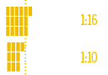The choice to use individual squares to represent the polyunsaturated ratio is also questionable, as the counting the blocks is both fiddly and redundant as the total number of blocks is also indicated by the second number in the ratio. They are also difficult to compare, as indicated in the image below: 1:16 is almost twice 1:10 but appears approximately the same height. Given the use of ratios, a log-scale (or similar) would have been more appropriate.

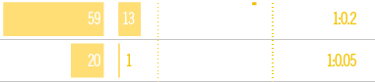A further problem with the ratio representation is that the text states that lower is better, however 1:10 is better than 1:16, and is also larger, but has a smaller bar. The confusion is compounded in cases where the ratio is greater than 1, where the bar is almost absent despite the ratio being highly desirable.

### Spatial grouping

As mentioned previously, the grouping of all bars together in the centre of the visualisation does emphasise the importance of these percentages, however the actual horizontal separation of each bar by whitespace can make it difficult to group all the bars related to a single oil. The interspersion of numbers (both inside and outside bars) further serves to break the visual horizontal continuity.

### Orientation

The individual percentage bars are inconsistently oriented left or right, which makes it difficult to compare and contrast relative levels of fat percentages, which is the primary visual query being performed. The choice of horizontal rather than vertical bars is understandable though, given the sheer number of oils being displayed (easier to scroll vertically than horizontally).

## Design heuristics

The following design heuristics are rules of thumb to evaluate the effectiveness of a visualisation, and are discussed below.

### No Unjustified 3D

3D effects are not used in this vis., and it is difficult to see how it would be used to add any additional information that would not be otherwise better displayed in 1D or 2D.

### No Unjustified 2D

The only 2D elements are the horizontal bars, and these are a fairly standard and effective element of visualisation.

### Eyes beat Memory

This refers to the idea that it is always better to be able to perform visual queries without having to remember information, because everything you need is already visible. This visualisation fails on this count, as the only comparison that can be achieved in this way is the comparison of percentages for a given oil. The unhelpful sort order and inconsistent presentation discussed above combine to require all other visual queries to utilise some element of memory. Additionally, since this is a static visualisation, using animation to mitigate these issues is not possible.

### Resolution over Immersion

This generally refers to choosing density of information over realism of interaction, however as this is a static visualisation, this consideration does not apply.

### Overview first, zoom and filter, details on demand

This generally refers to having important detail immediate visible, and then having additional detail available through interaction, however as this is a static visualisation, this consideration does not apply.

### Responsiveness Is Required

This generally refers to the latency of interactions, however as this is a static visualisation, this consideration does not apply.

### Get it right in black and white

This refers to the idea that a visualisation should work well in grayscale, without the need for colour. As evidenced below, this visualisation works on that criteria (though the overloading of luminance previously discussed does make it less effective than the coloured version).

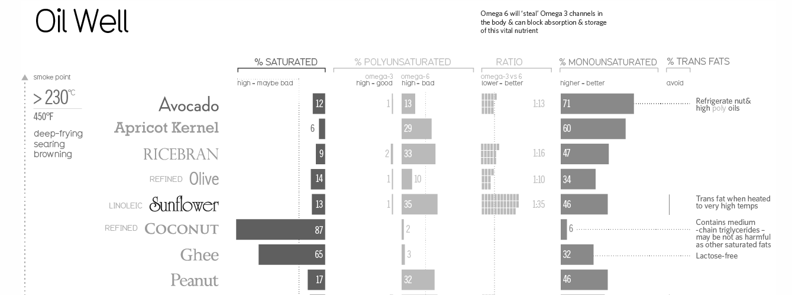

### Function, then form

This refers to the idea that the visualisation should prioritise effective interrogation by visual query over aesthetic considerations. This visualisation definitely falls short here (as discussed previously), as form has definitely been prioritised over function (though the balance is not as extreme as it otherwise might have been).

# Question 2: Design/Synthesis

The final re-design appears below – the original suffered from an excess of white, which performed badly together with all the luminance channel overloading. I’ve swapped to a primarily black background, both to make the colours brighter (relative colour appearance), and to emphasise the more restricted luminance channels that are used.

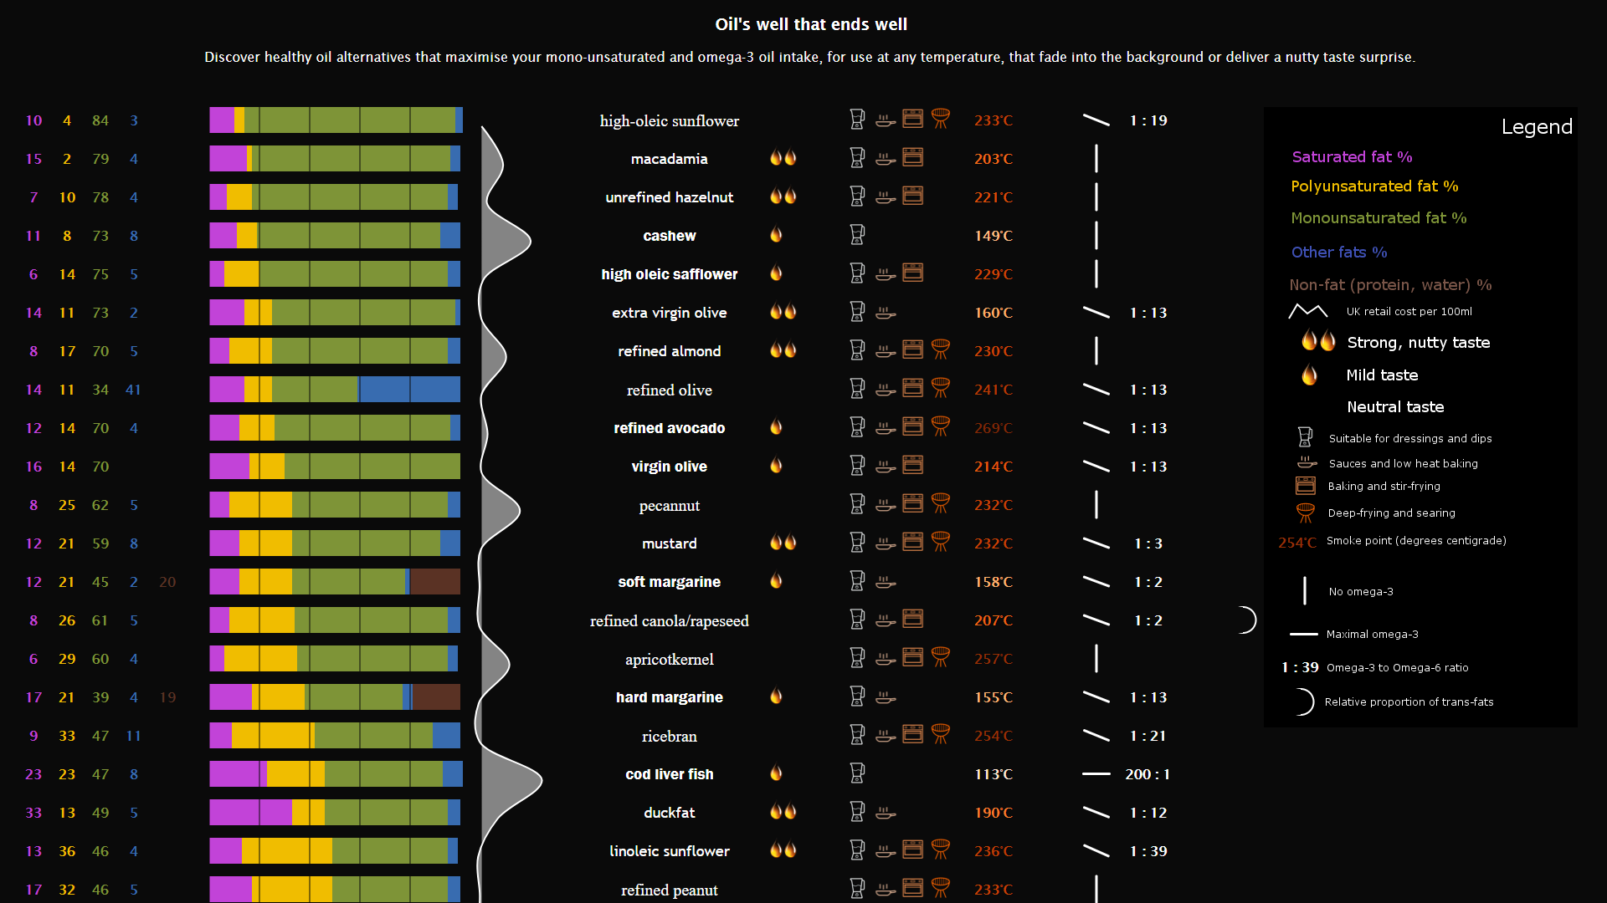

The first thing to check is that it still works in B&W (heuristic 7). I believe it does, though the colour bar luminances can clearly be tweaked to be more distinguishable.

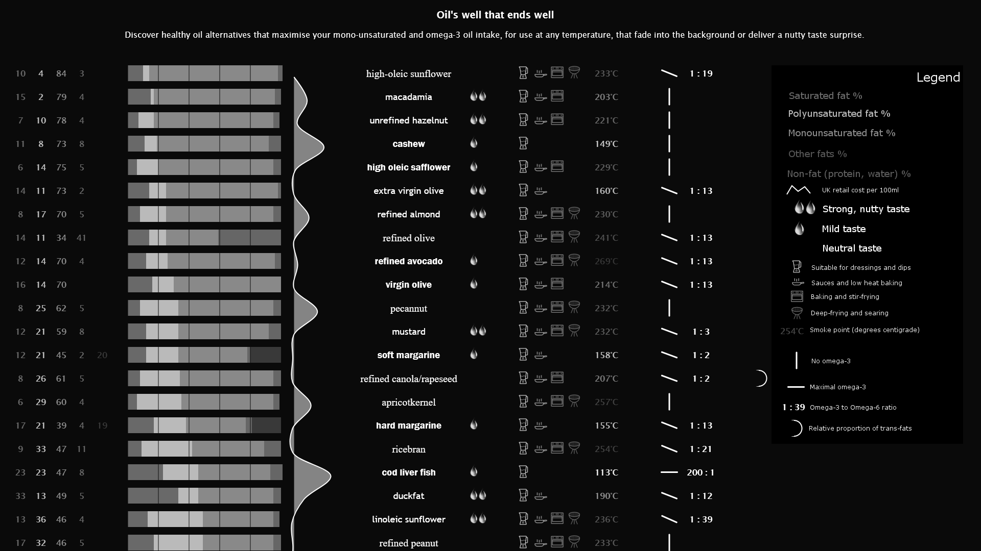

## Relative percentage display

For the redesign of the visualisation, I’ve focused on the primary visual queries presented previously. Specifically, in the original it is difficult to identify healthy versus unhealthy oils by comparing the scattered and inconsistent bar graphs. I have instead chosen to use a horizontal stacked bar chart per oil. The horizontal orientation is to maximise the use of the vertical space, and the stacks are sorted in decreasing order of the sum of saturated and polyunsaturated fats. This forces the healthier oils to the top, ensuring their importance to the user is matched by their spatial positioning.

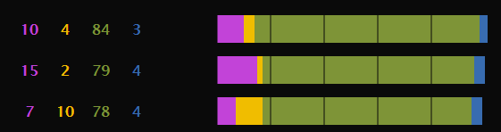

The use of the stacked bars also allows slightly easier comparison of relative proportions, though the usual drawback holds that categories not at either end are still difficult to directly compare. I’ve attempted to address this by including the actual percentages in a table to the left of each bar chart – this ensures that the detailed information is there if required, assists with relative comparisons (as it is possible to now simply look up the corresponding numbers and compare them), and avoids the number layout problems of the previous version.

The percentages and bars are consistently coloured to match the key in the Legend (discussed at the end), and instead of using explicit grid-lines I’ve used cut-outs at each 20% interval to allow rough bin quantisation of the bar lengths.

## Oil name, sub-type and taste

The second biggest issue with the original was visual noise created by the proliferation of fonts, such that meaning was frequently overloaded. In the redesigned version, only three fonts are used, each is exclusively mapped to one of the 3 taste profiles. I’ve also used the number of oil drops to indicate the same information. The oil drops also serve to add to the general gist of the visualisation, particularly the oily texture of the drop.

By mapping multiple channels to this one variable, I ensure that the user is easily able to identify oils that meet their preference (as taste is important to most people). The images below illustrate the result: on the left is a sample of the actual data; and on the right, the version that appears on the legend (note that the fonts haven’t been applied on the legend in the prototype, but would be in the final version).

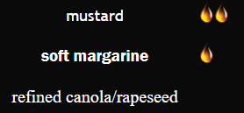 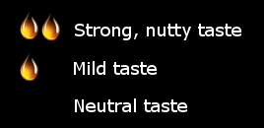

One additional point to note is that I’ve combined the oil name and sub-type into a single, homogenous display, which contrasts with the approach in the original. I believe the length of the total oil description is sufficiently differentiating, and that (as discussed above) visually differentiating the subtype is unlikely to provide any additional benefit.

## Smoke point

Another issue with the original was that the Smoke point was the ordering criteria for the entire visualisation, despite only being a secondary level query. The overloading of luminance to also represent applicability was also identified as a problem. The images below illustrate the new solution: on the left is the main content display, and the right is the legend explanation.

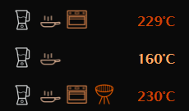 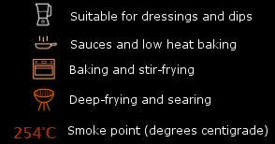

The redesigned version scraps the temperature scale and replaces it with 4 icons, each chosen to visually represent a specific mode of cooking, and to be visually distinct from the others in the set. The icons were then coloured on a quantized, colour saturation scale channel, with orange chosen as the colour because of its association with heat.

The use of the icons makes it clear that an oil can be used in potentially several different contexts (something that was not clear in the old version), and allows the user to quickly answer the questions “What is the best oil to use for sauces?” (pick the highest oil with the required symbol) or “Can I use this particular oil with this cooking method?”.

The precise smoke point (in degrees centigrade) is also displayed to the right of the icons (in a consistent location), and has the same colour saturation scale applied. This allows the user to quickly compare two oils with the same icon set to find which has the higher smoke point (use both numbers and colour saturation).

## Omega-3 to Omega-6 ratio

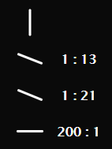As previously discussed, the original version handled the representation of this ratio poorly. I’ve scrapped the unnecessarily fiddly original version and replaced it with two simple elements: a line whose slope is vertical when there is Omega-3, and horizontal when there is the maximal ratio to Omega-6; and the actual ratio as per before.

This choice exploits the tilt/angle channel (very effective) to help the user quickly identify oils with good (nearly horizontal) ratios. I’ve also modified the ratio display for cases where there is more Omega-3 than Omega-6.

## Cost

The original version did not use Cost, although it is present in the underlying dataset. This is a large oversight as cost is a very important consideration for anyone considering using this information to make a lifestyle change. As such, I have included the relative cost as a simple line graph, with peaks aligned with the corresponding oil. This addition allows for quick comparison between equally healthy oils on a cost basis.

One possible tweak relates to the choice of a filled area graph – although the area below the curve is not meaningful (using 2D where 1D would suffice), I think the overall aesthetic effect outweighs the potential redundancy (as the important information is carried in the bright white line, rather than the lower opacity fill.

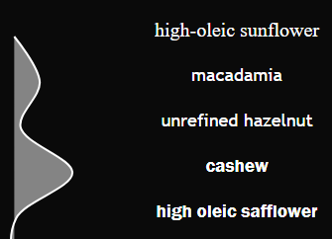

## Legend

The original version had instructions on how to interpret the elements scattered all over the design surface (most annoyingly, the flavour explanation is right at the end, in tiny font, that is easy to miss).

I’ve pulled together a legend that uses the exact same appearance as the main visualisation, and moved it to the top-right so that all necessary information on what each element means is immediately available. I’ve also visually separated the legend from the rest of the visualisation by using a slightly different coloured background.

## Shortcomings

There are several potential issues with this design that could be rectified in subsequent design iterations:

* This version has lost the interesting, informational pop out text of the original, primarily due to space utilisation. This could be fixed in an interactive version with hovering.
* The interpretation from the original (high omega-3 good, high omega-6 bad, low ratio good) has also been lost. I was hesitant to add it back as I’m both unclear that the science agrees with the claims, and because I couldn’t find a way to include them that was not jarring.
* I’ve included a curvature channel for the trans-fat proportion, but as the data points are few and the explanatory text is missing, it may be better to remove that element entirely.

## 

## Final Result

The final result appears below. I believe it is more informationally dense and usable than the original version, while also being reasonably aesthetically pleasing. It is also more compact than the original, with the entirety of the vis. able to fit on a single page (albeit at a small level of zoom).

